Ansible Assignment

Raparla Sravani

016656601

https://github.com/Sravani-05/Ansible272.git

**Problem:**

* Deploy three (3) Virtual Machines
* Configure Ansible server on ***VM 1***to deploy a webserver *to****VM2***and ***VM3***on port 8080 that displays the message: “Hello World from SJSU”
* Include in the Ansible playbook, plays to **deploy** and **un-deploy** all the webserver resources
* Due 9/11 (Sunday) at 11:59PM
* Submit a Word document via Canvas, with screenshots showing your work, and all ansible code/scripts via github

**Use Case:** Launching Ansible-based web servers and displaying the message "Hello world from SJSU-X." Depending on the server, X should be among 1or 2.

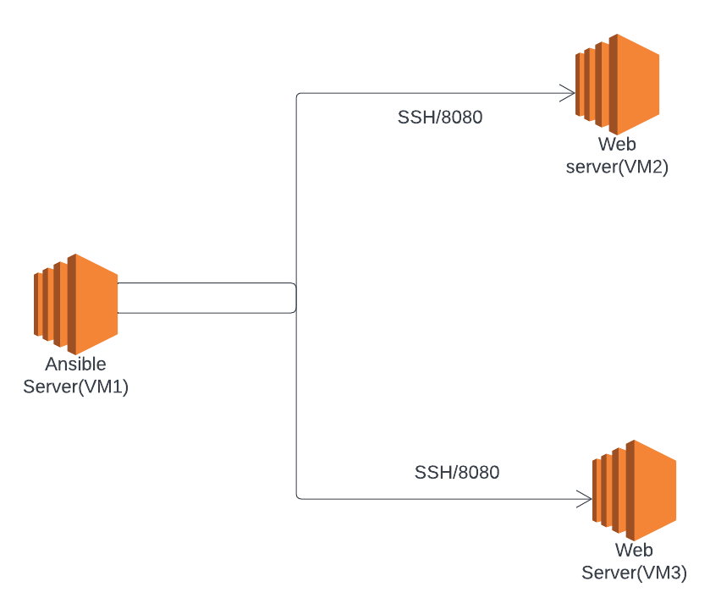

**Ansible Server**: Ansible is a tool installed on the server that uses YAML code to automate, deploy, or administer the pool of servers. Simply put, rather than repeating the same task, we can easily install the necessary software on a particular number of servers using Ansible.

**Web Server:** Server which hosts websites is termed as web server. It hosts the content of the websites.

**Solution:**

# Step1:

Build 3 virtual machines in which one acts as a central node VM to deploy apache2 web servers on two other managed nodes.

Below are the 3 VM’s deployed on EC2

Here

VM1 acts a central node VM

VM2, VM3 are Managed nodes

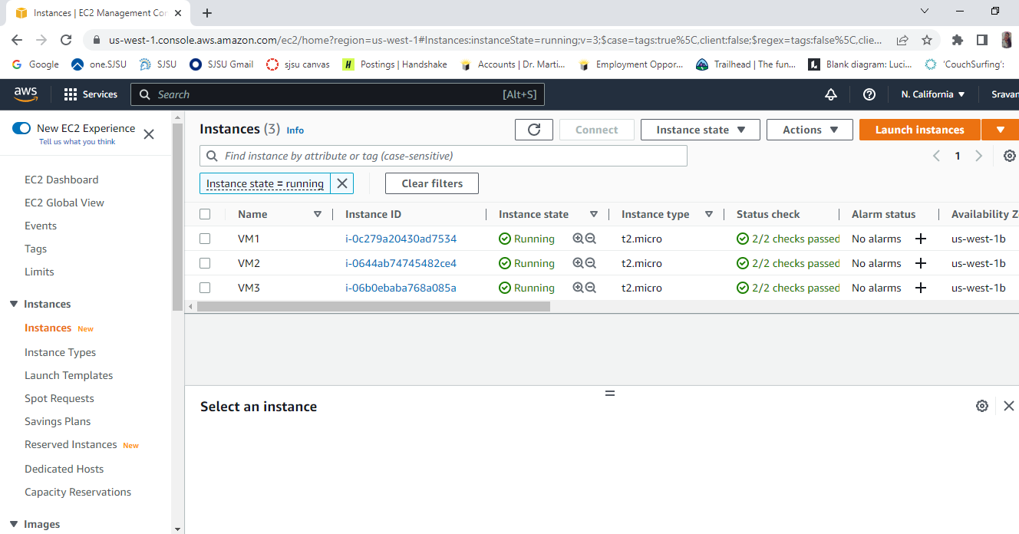

# Step2:

Install ansible on central node VM using below command

sudo apt install ansible

# Step3:

Setup Password less SSH login by generating a public-private key pair and exchanging the public keys between Central node and Managed nodes.

1. Command used to generate SSH key-pair : ssh-keygen -t rsa
2. Copied public key in id_rsa.pub to authorized_keys in other nodes

# Step4:

Update the host file - /etc/ansible/hosts with the IP address of Managed nodes

# Step5:

Create an YAML file to deploy webservers

Deploy Web Servers using command: ansible-playbook <yml_filename>

# Step6:

Uninstalling apache from VM

